xd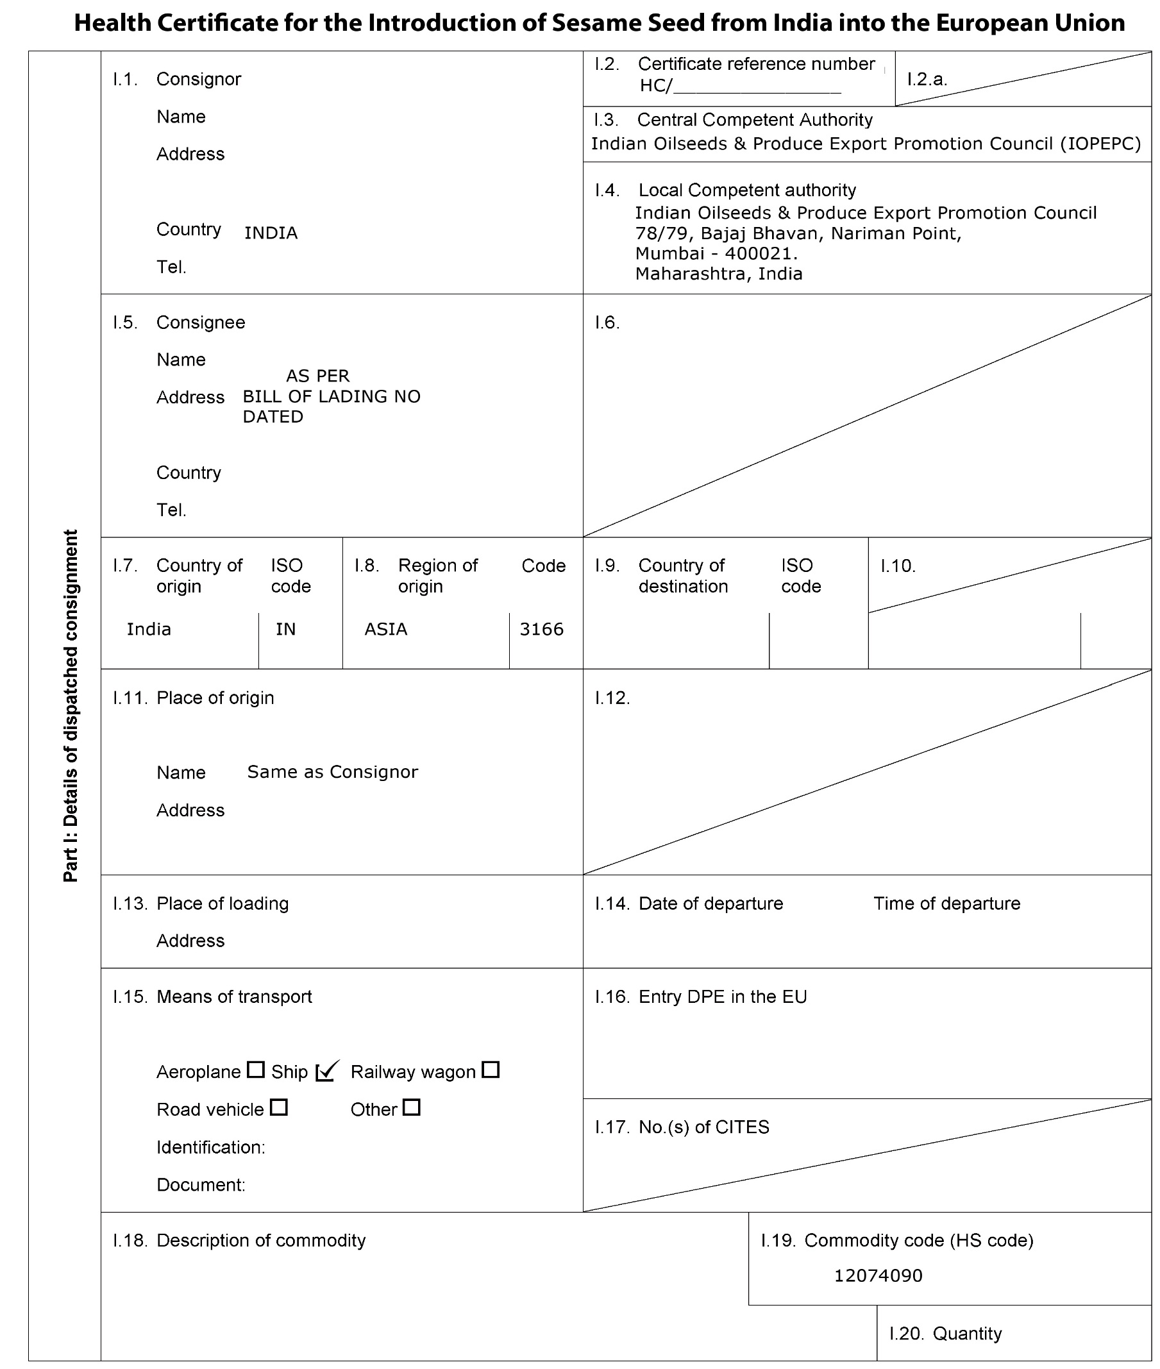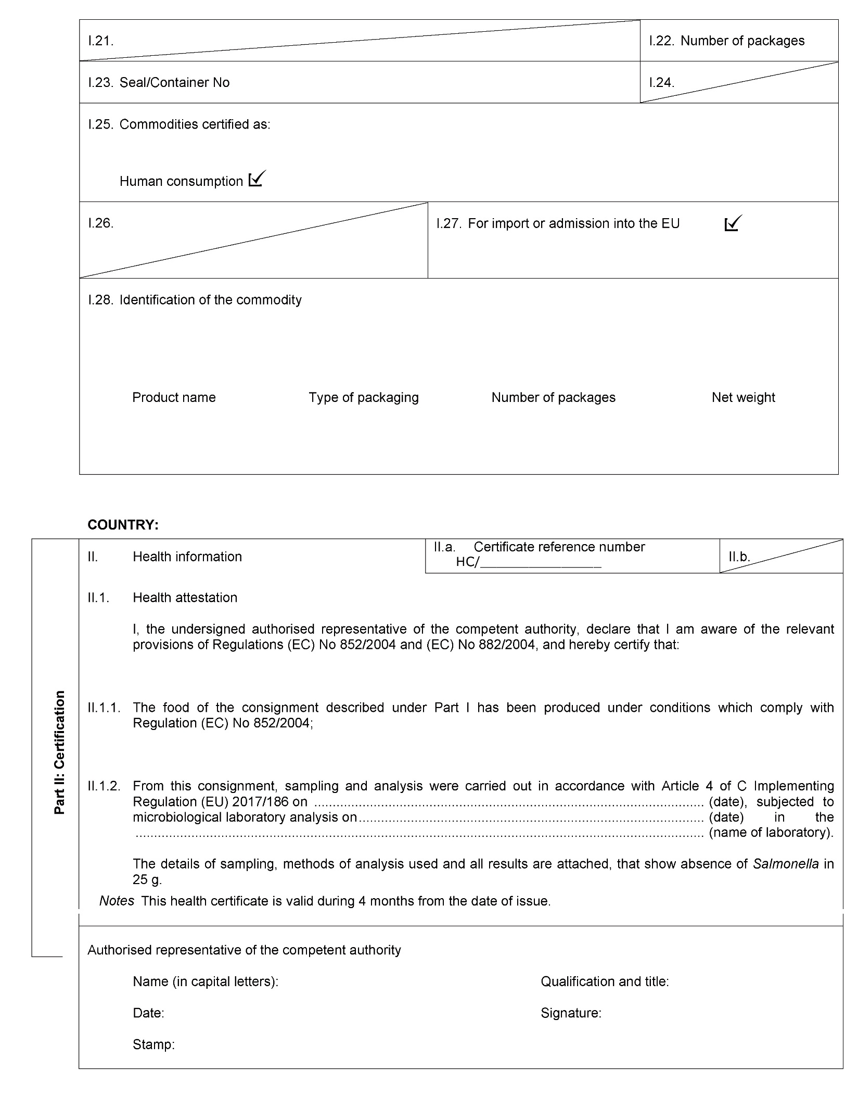
XXXXXXXXxxxxxxxxx

XXXXXX

XXXXXXXXXXXXXXXXXXXXXXXXXXXXXXXXXXXXXXX

NA

xxxxxxxxx

Xxxxxxxxxxxxxxxxxx
Xxxxxxxxxxxxxxxxxx
xxxxxxxxxxxxxxxxxx

xxxxxxxxxxxxx

xxxxxx

xxxxxxx
xxxxxx
xxxxxx
XXXXXXXXXXXXXXXXXXXXXXXXXXXXXXXXXXXX
xxxxxxxxxxxx

xxxxxxxxxxxxxxxxxxx

xxxxxxxx
xxxxxxxxxxxx

xxxxxxxxx

xxxxxxx
xxxxxxxxx

LOT No. - XXXXXXXXXX

XXXXXXXXXXX

XXXXXXXXXX

xxxxxxxx

XXXXXXXXXXX

XXXXXXXXXXX

XXXXXXXXXX

XXXXXXXXXXX

XXXXXXXXX

COUNTRY: INDIA

Health Certificate Annexure
Certificate reference number HC/ LOT No.- XXXXXXXXXX
Name of the Merchant Exporter: XXXXXXXXXXXXXX

Laboratory Analysis Details:

Commodity Name | Laboratory Name | Test Report NO | Sample  Drawn date | Analysis from | Analysis To
XXXXXXXXXXX | XXXXXXXXXXX | XXXXXXXXXXXX | XXXXXXXXXXX | XXXXXXXXX | XXXXXXXXXX

Stamp and signature of
Authorised representative of competent authority referred to in Article 5(2) of Implementing
Regulation (EU) No 2017/186

